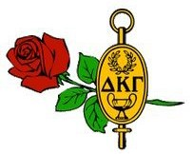
ALPHA XI NEWS
DELTA KAPPA GAMMA SOCIETY INTERNATIONAL
XI STATE
THE DELTA KAPPA GAMMA SOCIETY INTERNATIONAL PROMOTES PROFESSIONAL AND PERSONAL GROWTH OF WOMEN EDUCATORS AND EXCELLENCE IN EDUCATION.
NEXT MEETING

Volume 14 Issue April 2017

March Literacy Meeting

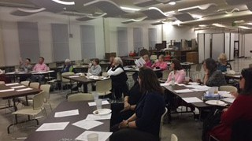The March litera- cy meeting was held downtown at the Chattanooga Public Library on March
Alpha Xi members at Chattanooga Public Library
16th. The Educational Excellenc committee
organized a tour of the Fourth Floor. Ann Pinion began the meeting with a meditation and introduction of our tour guide. Members were treated to a tour and informed of the many maker-space activities available from 3-D printing to sewing, publishing, and weaving. The committee graciously pro- vided finger foods and beverages, followed by the annual Grant-in-Aid
presentation. The 2017 recipient, Rebecca Boyer, attended with her parents.
Maxine Williams introduced members to this incredible young teacher in training.
Beverly Smith took the opportunity to honor members Lynn Meyer, Liz Morton, Janey Sue Massey, Peggy Wright, and Grace Kite in memoriam. She also recognized members of 5 and 10 years and those with more than thirty years of membership.
Suzanne Rushworth had asked that members bring a quote to share. Each person read their quote(s) and explained why they chose that particular
one. We had a great variety! Suzanne took the childrens' books which mem- bers brought to be delivered to Northside Neighborhood House. We had a
lot of books! Members also enjoyed the book swap.

Saturday May 6th Founders’ Day

PLACE:
East Brainerd Church of
Christ
7745 E. Brainerd Road Chattanooga, TN 37421

TIME: 10:30 a.m.
MENU: Chicken salad, Croissant, Fresh Fruit Salad, Dessert, Tea, Lemonade, Coffee
COST: $16

RSVP: Due to Karen Phillips by
April 17th (6603 State Line Rd.,
Chatt., TN 37412) OR Beverly
Smith by Monday, April 24th
(1398 Spitzy Lane, Soddy Daisy,
TN 37379)
PROGRAM: We will honor our Dis- tinguished Service to Education
Award to Karen Glenn. Speaker, David Carroll, WRCB-TV co-anchor.

Highlights & Photos of March Meeting

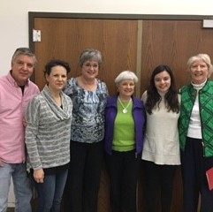

2017 Grant-in-Aid Recipient

Mr. and Mrs. Boyer, Beverly Smith, Nancy Franks, Rebecca Boyer, & Maxine Williams

Chattanooga Public Library 4th Floor Maker Space

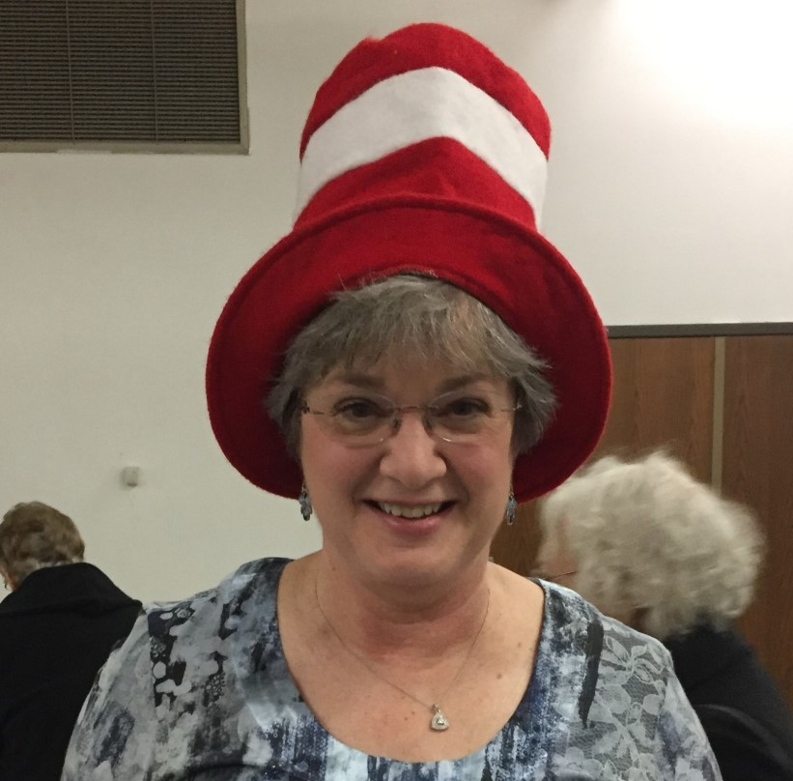"Thank you so much for the scholarship and letting me come to one of your meetings. All of the ladies were so kind and encouraging; it truly was a joy to be there. Again, thank you so much. I cannot wait to see where teaching takes me, and I hope to follow in the wonderful examples you have set."

The Prez in the Hat
Thank you, Rebecca Boyer

Announcements

Summer Picnic will be at the home of Julie Hughes
Tuesday August 1st.
8947 McKenzie Lane Ooltewah, TN 37363
344-9925
There is still time to register for Xi State Convention June 1-3, 2017.
You can download the form at http://www.xistate.org/forms/2017RegForm.pdf Registration fee increases $30.00 after May 1st

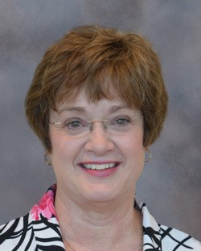
President’s Message
Do you ever stop to realize how enriched your life has been through your membership in DKG? Inter- national President Carolyn Pittman recently sent me the front page of a Little Rock newspaper. She had drawn arrows to a small blurb about an inci-
dent in Soddy Daisy. Aside from being amazed that Soddy Daisy would
Alpha Xi Officers
2016-2018
President Beverly Smith
bevsmith88@hotmail.com

make an Arkansas newspaper, we both reflected on the fact that Carolyn may
have never heard of a place called Soddy Daisy if it were not for our connec- tion through Delta Kappa Gamma. Through DKG we can develop close bonds with people we might never have otherwise known. Being a member of DKG allows us to meet and build relationships with amazing women who are dedicated educators. I never cease to be amazed by the talents, abilities, and community involvement of members of our chapter. I hope you’ll pause a few seconds to think about some of the DKG members who have touched your life. Think of their names; see their faces. Haven’t you been blessed to be a part of DKG? I certainly have!
Our next gathering will be with the other three Chattanooga chapters at Founders Day. I hope you’ll plan to be there to not only represent Alpha Xi but to build those DKG connections. The Xi State convention is a great op-
portunity to expand your connections beyond the chapter level. By attending the convention and volunteering to serve as a page, a table hostess, a mem- ber of the chorus, etc., you’ll meet even more amazing educators and future friends. What a blessing!!

First Vice President Suzanne Rushworth rushworth_suzanne@hcde.org

Second Vice President Ann Pinion anpinion@epbfi.com

Recording Secretary Jeanie McKenna mckennajean@gmail.com

Corresponding Secretary Joyce Campbell jckhanum@comcast.net

Treasurer Karen Phillips
kdpchattn12@yahoo.com

Parliamentarian Esther Clark
esthertajclark@gmail.com

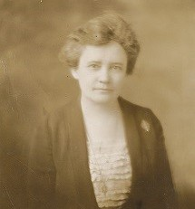
The Chattanooga Chapters will hold a joint meeting to celebrate Founders’ Day. Alpha Xi is responsible for decorations and the printed program. If you have a cake stand that we can use, please contact Bev- erly. We will decorate that morning around
8:30 or 9:00 a.m.
DR. ANNIE WEBB BLANTON
Founders’ Day Preview and Info

FOUNDERS’ DAY LINE-UP

The Chattanooga Chapters will Karen Glenn, director of STARS, with the
Distinguished Service to Education Award.

The guest speaker will be David Carroll, co- anchor WRCB-TV. He will be sharing stories from his book Volunteer Bama Dawg A TV-Guy’s Love
Letter to the South

MEMBER NEWS AND ANNO UNCEMENTS

Julie Hughes & Students Bring History to Life

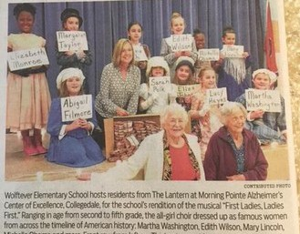Alpha Xi member Julie Hughes and her talented students presented “First Ladies, Ladies First”, an all-girl musical celebrating America’s first ladies from Martha Washington to Michelle Obama. Guests were residents from The Lantern at Morning Pointe, Alzheimer’s Center of Excellence in Collegedale. A story was featured in the

Julie Hughes poses with her all-girl cast and guests from Morning Pointe
Chattanooga Times Free Press Community News.

Alpha Xi receives high honors

Congratulations to Alpha Xi Chapter! Your newsletter and website have earned Highest Honors in Communications and Publicity.
These awards will be given during the Awards Luncheon on June 2 in Sewanee. I will also notify the Awards Committee as confirmation of this on your Maycie Award application.
Your chapter editor and webmaster are to be congratulated for maintaining highest standards of currency and content.
Jensi
Jensi P. Souders, Ed.D.

Xi State Scholarships Awarded

The Xi State Scholarship Committee is announced the following scholarship recipients for 2017:
Jamie Lawson (Alpha Rho) will receive the Maycie K Southall Scholarship for $3,000.
Kimberly Thurman (Alpha Xi) will receive the Louise Oakley Scholarship for $1,250.
Katherine Roovers (Pi) will receive the Evangeline Hartsook Scholarship for $1,250.
Brooke Sampson (Gamma Iota) will receive the Lottye McCall Scholarship for $1,250.

MEMBER CONCERNS

Eloise Litz took a fall over her cane and hurt her arm but nothing is broken. She is feeling better.
- Jim Cate was recently featured in a story on Channel 3 related to his battle with oral cancer. We continue to extend our hopes and prayers for the best for him and Norma.
- Marguerite Santich is struggling with her health. We have been unable to reach her by phone but understand her email address (santicht@bellsouth.net) has not changed, if you would like to contact her.
Joyce Campbell has sent cards on behalf of Delta Kappa Gamma, but they would all enjoy receiving calls and cards.

May Birthdays
5 Catie Wills

June Birthdays

4 Grace Kite

14 Jeanie McKenna

- Kay Sullivan

- Nancy Bibler

23 Nancy Franks

26 Cheryl Crow
If you know of anyone who has been recognized in any way, been sick, or experienced a death in the family, please contact Joyce Campbell so she can follow up.
jckhanum@comcast.net

Empathy is…
Seeing with the eyes of another
Listening with the ears of another Feeling with the heart of another

